**CSE 370 – Database Systems**

## **Theory Section 05 / 06 | Assignment 03**

## **Spring 2023**

**Full Name (in Block Letter): __________________________________ ID: _____________________**

**Question 1 [CO3] : 10 Points**

Apply appropriate rules to map the following ER schema to a relational schema.

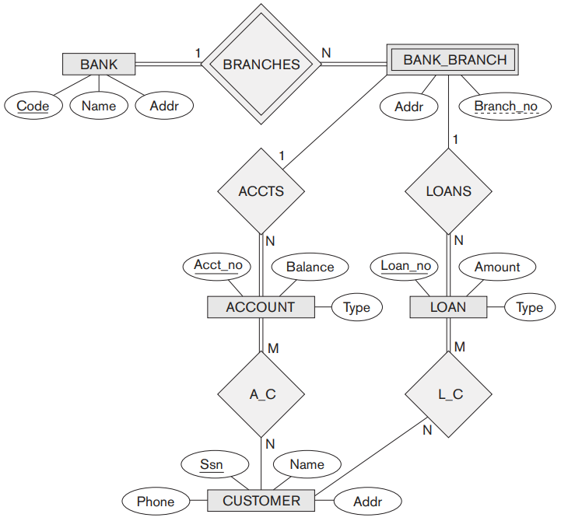

Figure : An ER diagram for a BANK database.

| **Answer:** |
| --- |